Problem Statement:

There is a road map of a (very small) city with circles representing halting/starting points and straight lines representing roads. All roads are two way. **Every circle is a traffic light of max-min wait time of 30 seconds each**. Vehicles have **average speed of 60 Km/Hr** on all roads (with no starting/stopping overhead). Whenever a vehicle reaches a traffic signal, it will **always find a red light**.

Question: Suppose Traffic signal X is traffic dependent, where a vehicle **takes 10 seconds to pass** it and only **one vehicle can pass at a time**. Traffic signal **remains green for 30 Seconds and red for 30 seconds**. Also, **traffic signal remains green in one direction at a time** i.e. if light is green on A-B path, vehicles can go in the direction A-B and B-A not across (E-D or D-E). Suppose there is a traffic control room to which a driver can call to get the fastest route between two points, Traffic control room also has the real time information of **how many vehicles are standing on X** **and in which direction.** **Assuming that traffic at X remains the same until the driver reaches there from any point,** write the algorithm to provide user with fastest route considering traffic situation at X and given distances and wait time.

For example: Driver calls from E and he/she wants to go to B, and at that time X had 3 Cars waiting to go from E-D and  3 Cars in the direction A-B .Driver will find those 6 cars waiting at X. Driver can pass through X only after those 6 cars have passed in the respective directions. That means waiting time of 2 minute at X itself + travel time between E to X and X to B, considering all this, fastest route will be E-B.

Input: Start Point, End Point and number of Cars waiting at X in AB/BA direction and ED/DE direction

Output: Fastest route and time

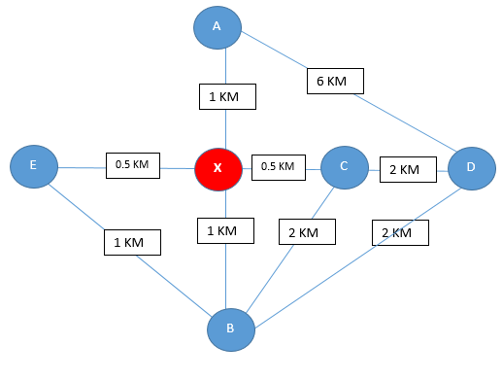

Assumptions

The signal can have traffic from four directions or less.

The traffic should be specified at the signal (in form of directions i.e. North, South, East, West)